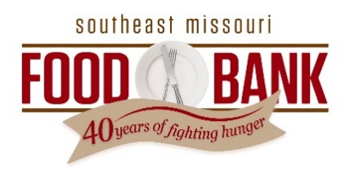
News Release
For Immediate Release
Contact: Heather Collier
573-475-7573
hcollier@semofoodbank.org

Registration Opens for 14th Annual SEMO Food Bank Golf Classic
SIKESTON, Mo. (July 15, 2025) – Registration is now open for the 14th annual Southeast Missouri Food Bank Golf Classic, taking place Monday, Sept. 22, at Dalhousie Golf Club in Cape Girardeau.
The four-person scramble begins with a 12:30 p.m. shotgun start and includes lunch and refreshments throughout the day. All proceeds support SEMO Food Bank’s mission to end hunger across southeast Missouri.
“This is our biggest fundraising event of the year, and we’re so grateful for the support we receive from everyone who takes part,” said Joey Keys, chief executive officer of SEMO Food Bank. “The funds raised help us provide food to families throughout southeast Missouri. That support means even more this year as we face rising need and fewer food donations and federal resources. We also appreciate Dalhousie Golf Club and its staff for once again hosting us on such a beautiful course and ensuring our players have a first-class experience.”
Sponsorship opportunities start at $500, with team-only registration available for $1,000. To register, visit https://fundraise.givesmart.com/e/hdGBjQ?vid=1k3718 or contact Heather Collier at hcollier@semofoodbank.org.
“We’re fortunate to have incredible support from businesses and community members,” Keys added. “Many sponsors return year after year, and we’re grateful they continue to stand with us in the fight against hunger.”
Southeast Missouri has some of the highest hunger rates in the state, with 1 in 6 individuals and 1 in 4 children living in food-insecure homes. SEMO Food Bank serves about 80,000 individuals each month across 16 counties through its network of partner agencies and direct-service programs.
For more information, visit semofoodbank.org.

# # #

About Southeast Missouri Food Bank
The mission of Southeast Missouri Food Bank is to end hunger and leverage the power of food to build healthy communities. The food bank provides food to 140 charitable and disaster relief programs in Southeast Missouri. These member agencies include food pantries, soup kitchens, domestic violence and homeless shelters. Southeast Missouri Food Bank also holds regular mobile food distributions and provides monthly boxes of food to 5,600 senior citizens and weekend backpacks of food during the school year to 1,100 students in area school districts. The food bank’s 16-county coverage area includes Bollinger, Butler, Cape Girardeau, Carter, Dunklin, Madison, Mississippi, New Madrid, Pemiscot, Perry, Reynolds, Ripley, Scott, Ste. Genevieve, Stoddard and Wayne counties. Those interested in helping can do so by making a tax-deductible contribution, donating food, or scheduling a time to volunteer. Visit semofoodbank.org for more information.

